Instructor: Dr. Steve Peng

MGMT 6155 – Applied Project Management – Spring 2018

**SolAR Power Project**

**Work Breakdown Structure**



Anton Kurayev, Bryan McMaster, Bruce Curtis, Duy Ly, Thao Dinh, Trung Phan, Tuan Truong

*May – 2018*

Contents

Introduction and Project Background 3

Project Scope 4

Objective 4

Deliverables 4

Milestone 4

Technical requirements 4

Assumptions and constraints 5

Work Breakdown Structure 5

Phase 1: Feasibility study 5

Phase 2: Planning and design 5

Phase 3: Construction and building 6

Phase 4: Training 6

Phase 5: Turnover 6

Estimating Project Time and Costs 8

Estimating Phase 1 8

Estimating Phase 2 8

Estimating Phase 3, 4, 5: 9

Managing Risk 9

Scheduling Resources and Costs 11

Scenarios 16

Scenario 1 - New Inverter Requirements 16

Scenario 2 - Main Breaker Derated 16

Conclusion 18

# Introduction and Project Background

Our company was picked to install solar for the Tragon Building. In this paper, we will show how we defined the constraints and requirements and fulfilled the customer requests using project management techniques.

Our company, approached by the owners and management of the Tragon building for a solar power project to be installed on the roof of their building. The start date was May 16, 2018, with a deadline of ten months out. We estimated the total cost to be 1 million dollars. Our team took on the project, and the following is the details of our findings and results of the project.

The owner is insistent that it will need to be a roof mount, it must not cost more than one million dollars and completed in ten months from May 16, 2018. We will try to be as efficient as possible as we know that different scenarios can occur that can become problematic and can delay the project or take from our resources.

For this project, we will be going from a feasibility study to the handoff to the customer. We will first do a feasibility study, along with an analysis of the current usage to see how large of a solar electric system the building would be able to install to optimally offset the usage. Once we receive a go-ahead from the building owner, we will start on planning. After reviewing all requirements for the installation, we can then proceed with design and procurement. After getting all our needed equipment and are ready for construction, we can install our system and begin training our personnel and begin the hand off to the customer.

# Project Scope

## Objective

Install solar panels on the Tragon building’s roof in 10 months at a cost not exceed $1 million.

## Deliverables

* A feasibility study.
* The scope of the project includes the following deliverables:
* Installation of solar panels.
* Training of building maintenance team.
* Construction drawings\specifications, generation of solar power electricity

## Milestone

After some careful planning we found the following milestones would make the most sense for the overall project.

* 7/3/2018: Feasibility Study
* 12/18/2018: Planning and design done
* 2/12/2019: Solar panels, batteries, shelters transformers and connectivity installed
* 1/23/2019: Training program for the building maintenance staffs completed
* 2/13/2019: Turnover tasks done

## Technical requirements

The scope of the work also includes our technical requirements. First, to meet state requirements we must adhere to these criteria: All the equipment must meet California Energy Commission standards, the solar modules must pass the test under the standard test conditions and meet the installation requirements of CalFire. Second, in addition to state requirements, they must meet the requirements set by the electric utility as well as the local county. Third, each building maintenance staff is trained for at least twenty hours. Lastly, construction should be on time and within budget.

## Assumptions and constraints

There are certain assumptions about the project, and they are listed here:

* Permits are already acquired.
* Electrical demand for the building’s operation will not change
* Existing site conditions on the property and around the building will not impede construction
* On-site storage areas for construction materials are available
* Normal daytime working hours allowed (0700-1700)

Constraints for the project include:

* The budget for the construction and materials will be fixed once contracts are awarded
* Long lead time required for the procurement of some materials
* The building will remain occupied, and business operations will continue throughout the project.
* No full-time security staff – materials will need to be secured on-site to avoid theft.

# Work Breakdown Structure

## Phase 1: Feasibility study

Perform a feasibility study to determine the cost, cost savings, and tax rebates for the project. The project team will conduct required analyses such as risk and electrical/solar load. By the end of this phase, the results of the feasibility study will be presented by the pthe roject team. The owner will receive the necessary information to authorize funding for design and construction.

## Phase 2: Planning and design

The project team works on the construction drawings and specifications. Statement of work will be composed to cover all requirements. Project requirements are classified into different categories: general, structural, and electrical. Also, work schedule and cost estimate will be prepared by the project team. RFQ and contracting processes included in this phase as well.

Another significant activity of this phase is to obtain needed permits and approval before proceeding to the next phase. Finally, procurement is considered to facilitate the project execution, making sure that the project will not be delayed due to procurement waits.

## Phase 3: Construction and building

Equipment is installed according to the design with minimal changes. By the end of this phases, solar panels, transformers, batteries are installed, and connections are setup correctly.

## Phase 4: Training

Provide 140 hours of training to the building maintenance staff to operate and maintain the solar power system. Building maintenance staffs must be fully capable of operating and maintaining all batteries and transformers.

## Phase 5: Turnover

Acceptance documents are reviewed by the project team and owner at time of turnover. The deliverables must meet all owner acceptance criteria and accepted by the owner. Release liens and paying general contractor involved in the project are to be done.

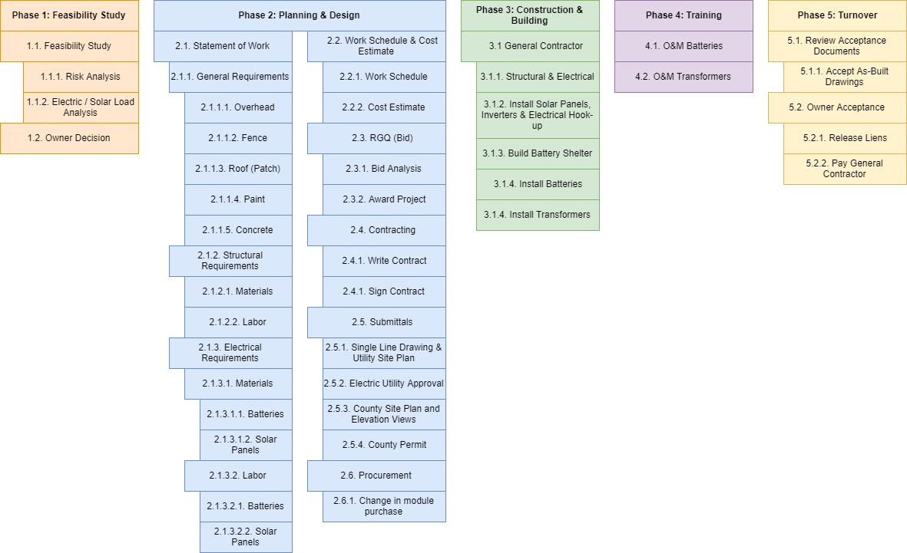

Figure : Work Breakdown Structure

# Estimating Project Time and Costs

When estimating the time and costs, we used the bottom-up approach.

* Phase 1 - Feasibility ($35,700)
* Phase 2 - Planning & Design ($2,620)
* Phase 3 - Construction/Building ($473,000)
* Phase 4 - Training ($15,000)
* Phase 5 - Turnover ($10,000)

We used multiple Bottom-Up approaches to estimate the cost and time for our project. Primarily, two methods, which are Template method and Parametric Procedures Applied to Specific Tasks method, are applied:

## Estimating Phase 1

The cost baseline of this section is estimated mostly from the previous project with similar tasks (template method). Specifically, the total cost of this phase is $35,700 which comprises of $35,000 of first three tasks (same as the past project), and one more section for a license (additional task) which will cost $700 particularly in Hayward (based on the government permit fee table).

## Estimating Phase 2

For Planning and Design cost, we use Parametric Procedures Applied to Specific Tasks technique to estimate the total expense. In detail, we figure the cost of first stage Statement of Work will take up 8 work hours and every work hour will cost $40. This stage includes four subtasks, which are General requirements (need 2 work hours and will cost $80), Structure requirements (need 2 work hours and will cost $80), Electrical requirements (need 3 work hours and will cost $120), and Labor (need 1 work hour and will cost $40).

In the second stage Work Schedule & Cost Estimate, we also use the same method. Notably, this stage requires three work hours which are two in Work Schedule (cost $80) and one in Cost Estimate (cost $40)

Third stage RFQ requires two work hours for Bid Analysis ($80) and fourth stage Contracting will require three work hours for Writing contract ($120). Similarly, in fifth stage, Submittals requires seven work hours which are 4 in Single Line Drawing & Utility Site Plan ($160) and three in County Site Plan and Elevation Views ($120)

Electric Utility Approval and County Permit stage cost is estimated based on the cost from the previous projects. Finally, the cost of Procedure stage will take three work hours (cost $120). The total cost for this phase is $2,620.

## Estimating Phase 3, 4, 5:

Costs from last three phases are estimated from the cost template of the former project. Specifically, Phase 3 will cost $473,000, Phase 4 is $15,000, and Phase 5 is $10,000.

The total expense to implement new Solar Power System as planned will cost up to $535,620 in five phases. Phase 3 Construction and Building will cost the most in the project.

The timeline from the previous project is used to estimate for all of the task durations. Initially, the project duration is 26 weeks; however, due to incidences, the project may be delayed by

* Five working days in stage 2.6 (new Requirements on inverters - Need to be UL-1741 SA compliant)
* Five working days in stage 3.1.1 (due to derating of the main breaker of the electrical panel, the utility has to reschedule)
* Ten working days in stage 3.1.2 (Solar owner does not receive an extension of credit and must receive panels from another provider)

***The project duration after rescheduling is 30 weeks.***

# Managing Risk

We managed risk by creating a risk assessment matrix (Table 1) and a risk response matrix (Table 2) based on the potential risks that we brainstormed may happen during the project. These risks included injuries or sickness, extreme weather conditions, inadequate staffing/training, materials or parts are damaged, and a replacement is required.

The risks as shown in the Risk Assessment Matrix demonstrate the likelihood the event might occur and its impact on the project. All indexes will be on a scale of one to five, with one being the lowest and five being the highest. For example, a construction worker likely has a chance to experience an injury himself during the task since the work requires to carry and lift heavy parts. As the project started with only two construction workers, therefore; if one called in sick and experienced an injury, it is going to impact the project schedule. To ensure our project is completed on time, we encourage a contractor to wear industrial support belt with suspender and might need an additional headcount from the vendor to backup.

|  |  |  |  |  |
| --- | --- | --- | --- | --- |
| **Risk Event** | **Likelihood** | **Impact** | **Difficulty in Detection** | **When** |
| Worker Injuries | 3 | 4 | 1 | During task |
| Extreme Weather Conditions | 4 | 5 | 3 | During task |
| Poor Staffing | 1 | 4 | 3 | During task |
| Defective Parts | 2 | 3 | 2 | During shipping and installing |

Table : Risk Assessment Matrix

|  |  |  |  |  |
| --- | --- | --- | --- | --- |
| **Risk Event** | **Response** | **Contingency Plan** | **Trigger** | **Responsible Person** |
| Worker Injuries | Reduce | Ensure availability of first aid kit,  Backup resource needed | Poor health, upon injury ... | Team members  Team leader |
| Extreme Weather Conditions | Accept | Ask for immediate help | Poor weather conditions, heavy rain, hurricane... | Project Manager |
| Poor Staffing | Reduce | Use different resource | After 1 hour | Team Leader |
| Defective Parts | Accept | Select a reliable vendor  Reorder parts | Damaged parts | Team Leader  Project Manager |

Table :Risk Response Matrix

# Scheduling Resources and Costs

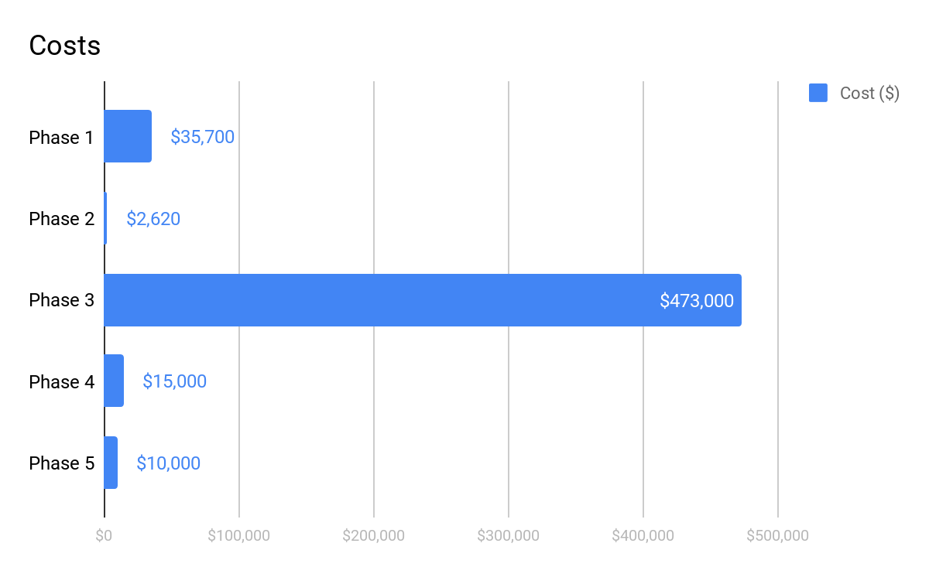For human resources, we will need a project sponsor at $100 per hour for 128 hours, a project manager at $80 an hour for 648 hours, lawyer for any legal issues that may arise at $367 per hour for 80 hours, and a total budget for these resources is $94,000. In addition, two construction workers billing at $20 an hour to be allocated to the job site for varying duties and tasks in the WBS, for a total of 544 hours. One electrician billing at $30 an hour to be used for any electrical jobs in the WBS, for a total of 600 hours and finally a solar specialist billing at a rate of $40 an hour for for a total of 680 hours, in total we have budgeted $56,080 for these workers. 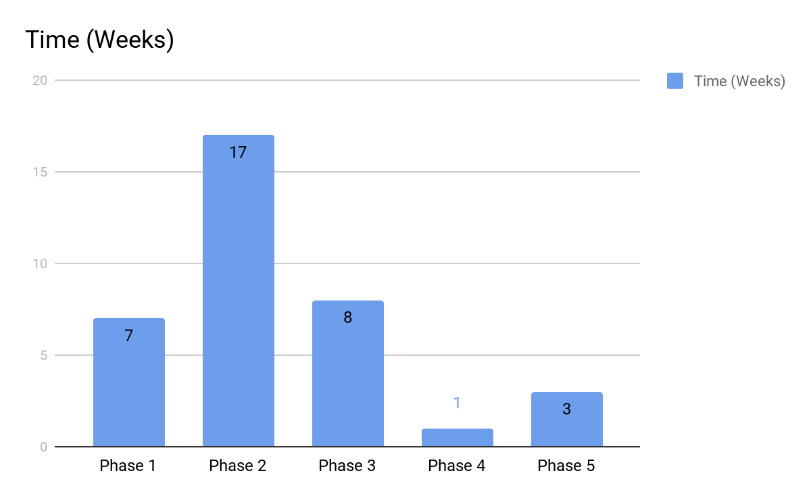

Figure : Costs by phase

Figure : Timing of each phase

|  |  |  |  |  |
| --- | --- | --- | --- | --- |
| **Resource’s Job Title** | **Number of Resources Needed** | **Billing Rate per hour** | **Number of Hours Required** | **Total** |
| Project Sponsor | 1 | $100 | 128 | $12,800 |
| Project Manager | 1 | $80 | 648 | $51,840 |
| Lawyer | 1 | $367 | 80 | $29,360 |
| Construction Worker | 2 | $20 | 544 | $10,880 |
| Electrician | 1 | $30 | 600 | $18,000 |
| Solar Specialist | 1 | $40 | 680 | $27,200 |
|  |  |  | **Total** | **$150,080** |

Table : Resources

The Construction workers, electrician and solar specialist are all constrained resources. It turned out these resources highlighted in red shown in Figure 4 below are overallocated. This will impact or change the critical path, and likely use the slack that has been added to the project.

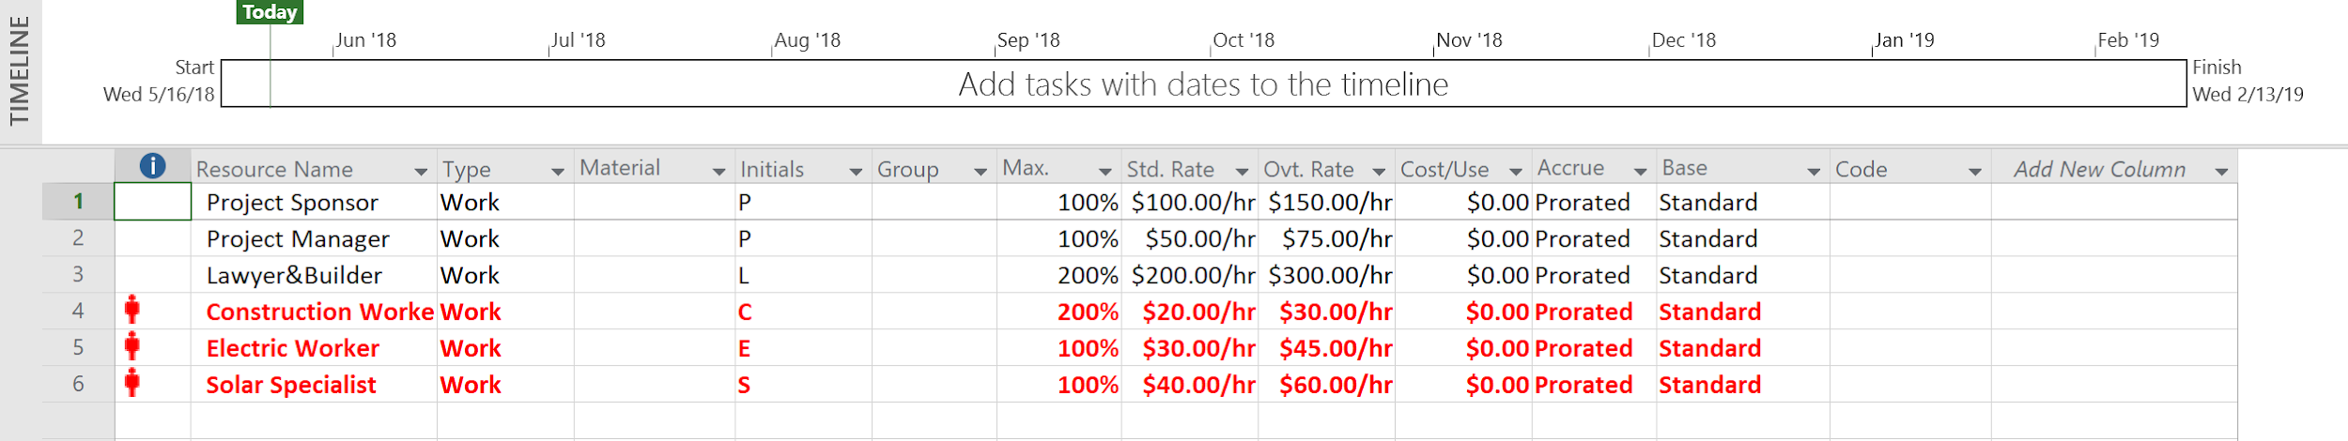

Figure : Overallocated Resource Sheet in Microsoft Project

To resolve this resource issue, ***the project will need the extra headcounts of 1 constructions worker, 1 electrician, and 2 solar specialists***. 100% in the Column Max. represent 1 headcount. For example, solar specialist shows 300% meaning the project will need three headcounts to help resolve the overallocated issue.

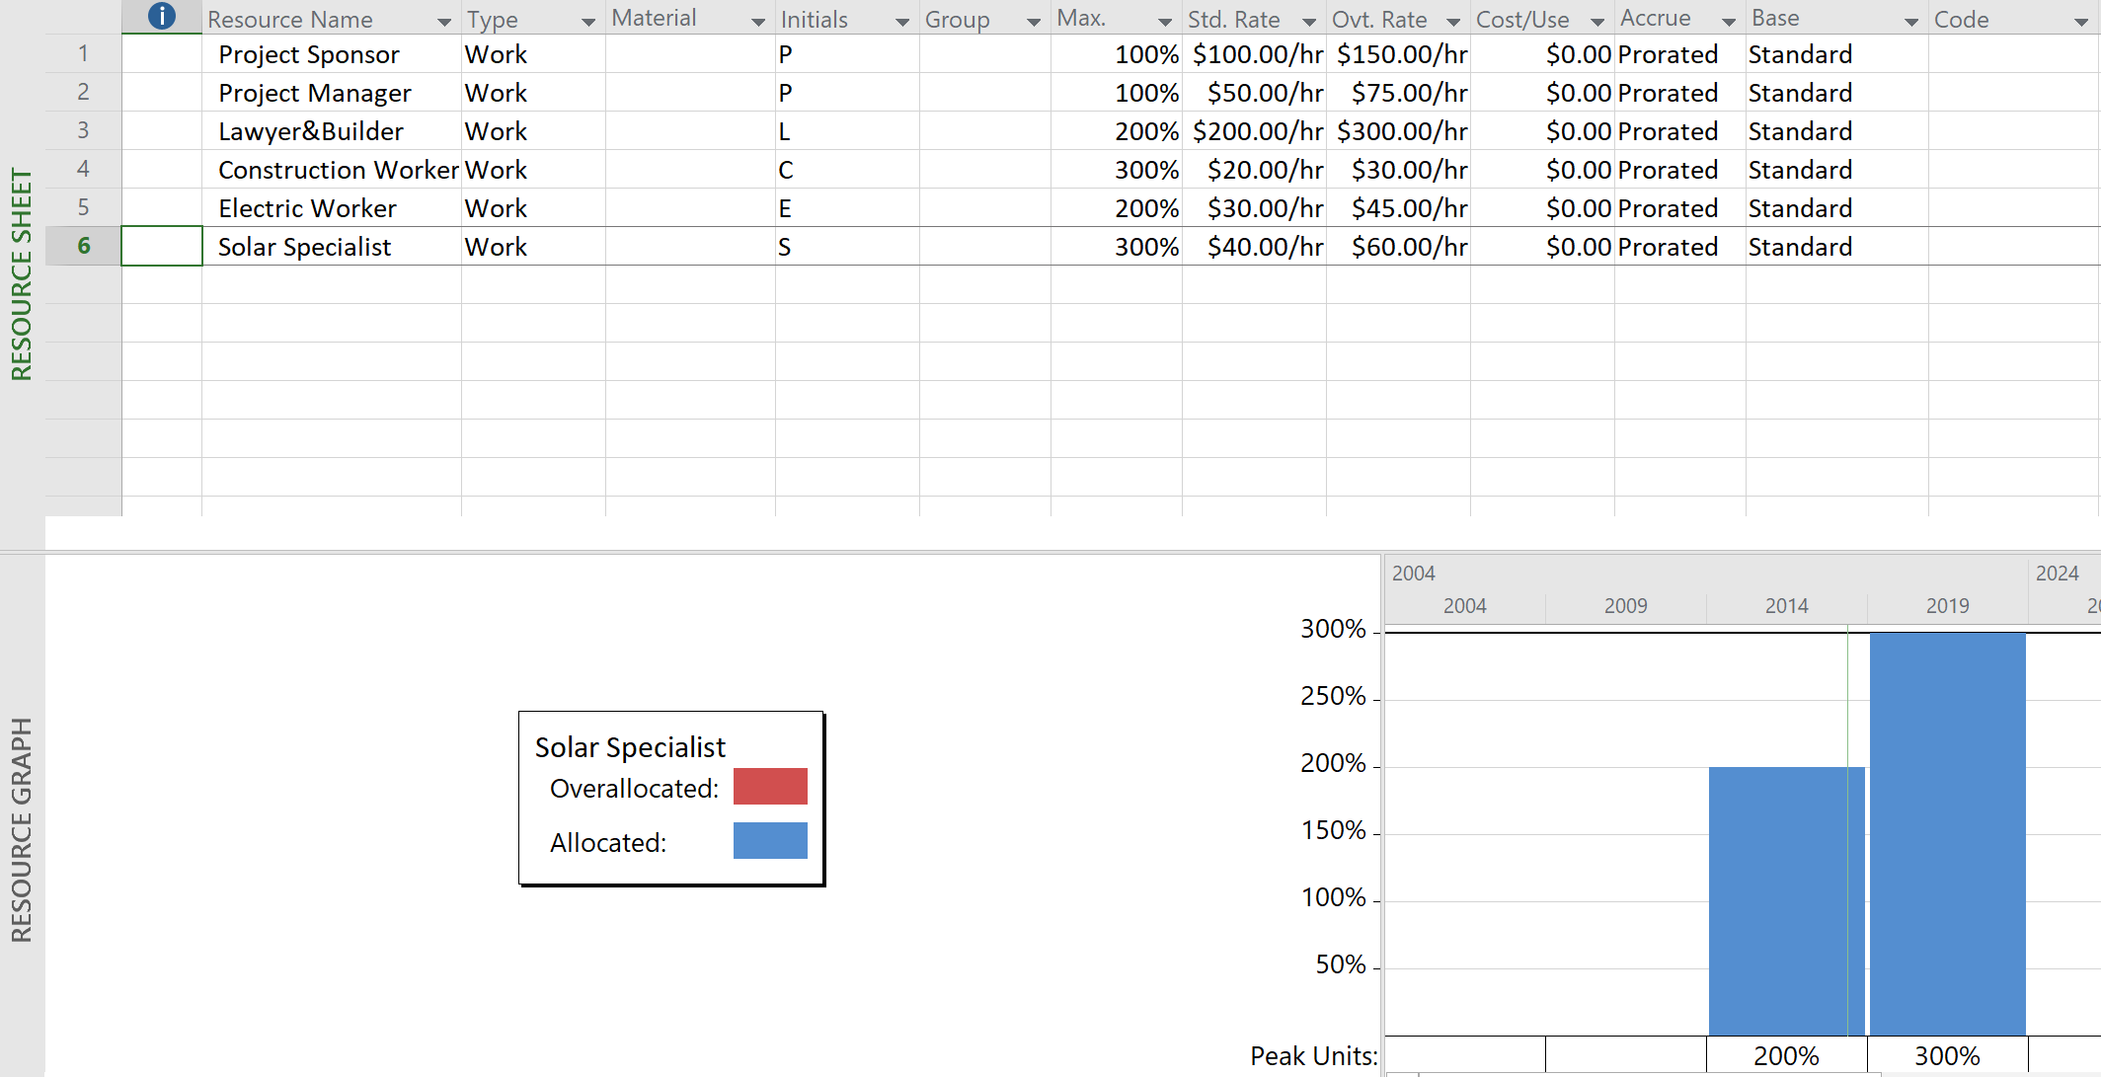

Figure :Allocated Resource Sheet in Microsoft Project

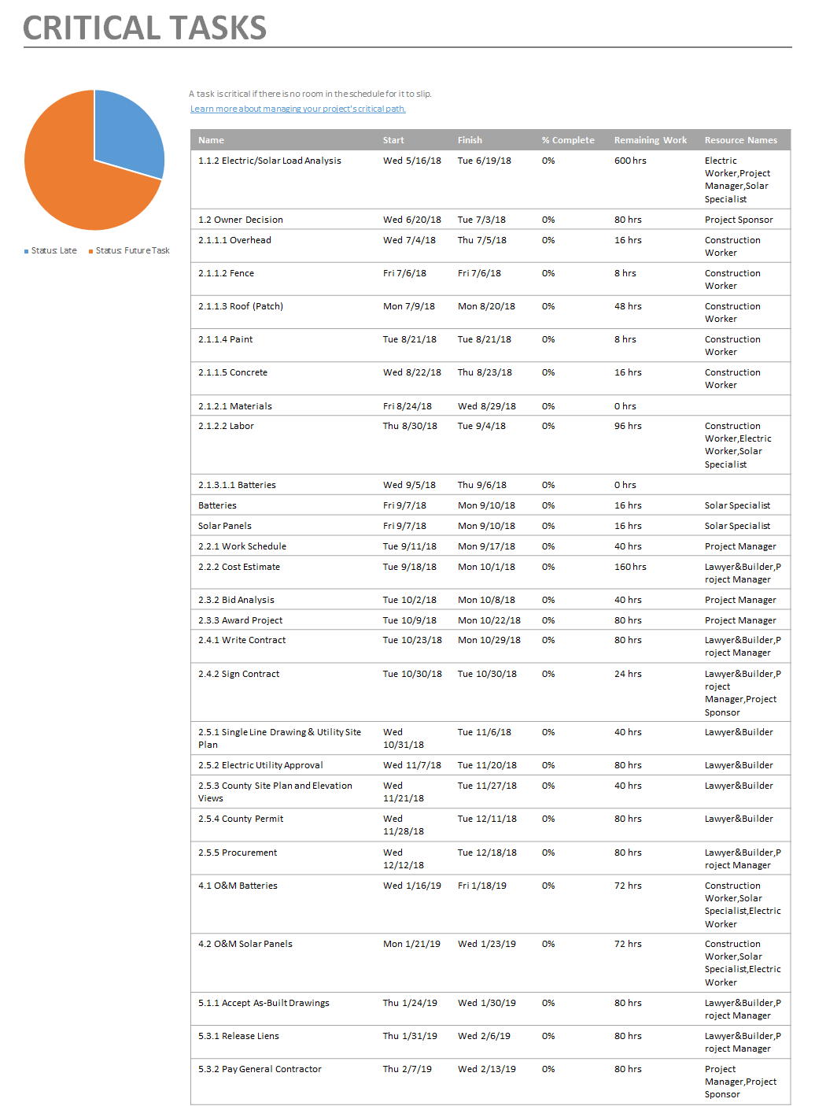

Figure :Critical Tasks

The bulk of the materials cost for the project is the batteries and solar panels. There will need to be three batteries, 100 kWh Energy cell 2200NC Solar Battery Storage at a cost of $26,000 each for a total of $78,000. The solar panels, specified as Cell Mono Solar Panels with a length and width of 65”X39”. The solar models for rooftop are made up of 60 solar cells. We will need at least 400 of these at a charge of $250 per panel, totaling $100,000. The vendor has already agreed that unused or defective panels are okay to return. Other parts like transformers, connectors, wiring, and meters are approximately $5,000.

Figure : Gantt Chart - Ctirical Path

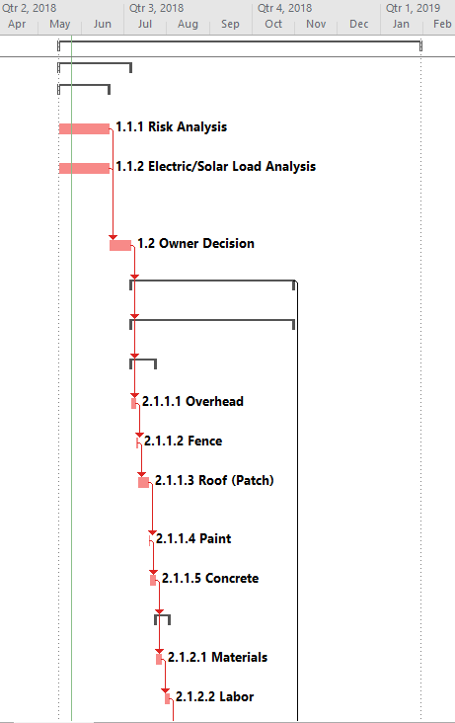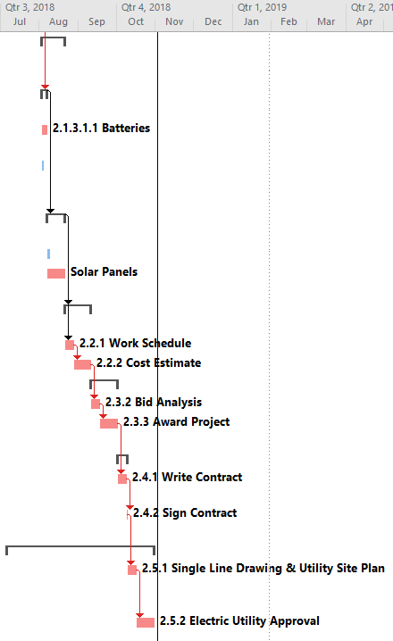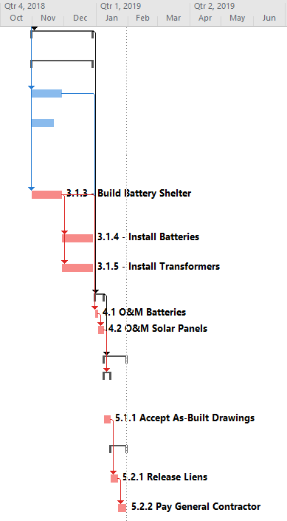

The project will take 179 days, approximately 26 weeks with 23-week (117-day) total slack. Starting on May 16, 2018, Solar Power panel project will be finished by Jan 1, 2019.

Except: 2.1.3.1.2 (Solar Panels), Batteries (2.1.3.2 Labor), 2.5.3 County Site Plan and Elevation Views, 2.5.4 County Permit, 2.6 Procurement, 3.1.1 - Structural & Electrical, 3.1.2 - Install Solar Panels, Inverters & Electrical Hook-Up. All other activities are on the critical path.

A sensitive network would be one with more than one critical path and noncritical activities with very little slack. With that being said, in this case, it has only one critical path and non-critical tasks with a quite low value of slacks. Therefore, as project managers, we should devote much attention to managing the critical path.

# Scenarios

We were surprised by three significant scenarios. These scenarios ended up extending our project by 5 weeks. The scenarios were as follows:

1. New Inverter Requirements from the electric utility
2. Main Breaker Derated
3. Solar Panels delayed

## Scenario 1 - New Inverter Requirements

Unbeknownst to our team, there was a new inverter type required by the Electric Utility. The electric utility rejected the single line drawing that we submitted for approval because the inverters we had proposed were not UL-1741 SA compliant. ****This needed change in design was turned around the same day. The single line drawing was updated and returned to the electric utility. The electric utility approved the drawing five business days later.

## Scenario 2 - Main Breaker Derated

Due to what is called the 120% rule in the National Electric Code (NEC), our PV system is larger than what can be accommodated in the main panel due to the relatively large size of the main breaker. This was not initially captured in design and was a significant roadblock. The team had mistakenly shown a smaller main breaker in the single line drawing and the team knew that the problem had to be fixed if they were going to be interconnected.

We were left with two legitimate options: A. work with the electric utility to have the main breaker replaced with a smaller one, or B. reduce the system size. Replacing the main breaker would cost $3,060 and take five days. Alternatively, we could reduce the system size; this would require coordination with the owner. The owner was adamant about keeping the system size initially discussed, and decided to go with option A.

**Scenario 3 - Solar Panels Delayed**

Due to a credit issue with the existing panel distributor, the panels needed for the project would not be on credit. Our team had two options: A. Go to a different distributor, B. Reduce the system size. Option A would extend the project by ten days, which we would leave us on schedule. Option B turned out to be unacceptable since, as seen in scenario A, the building owner was adamant about keeping the system size proposed. Option A was chosen.

Figure : New Timeline Gantt Chart with Scenarios

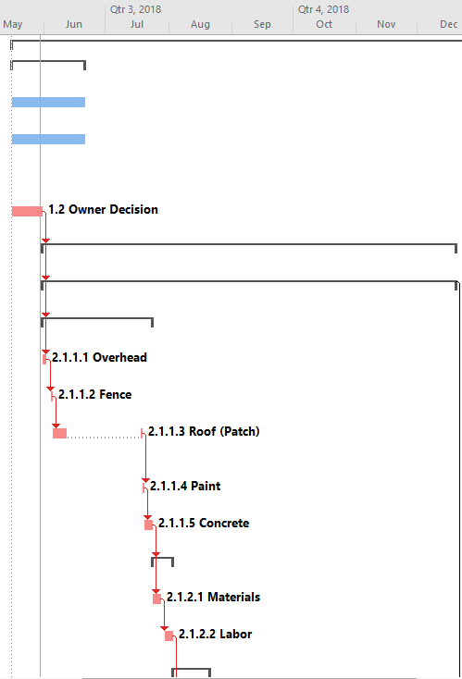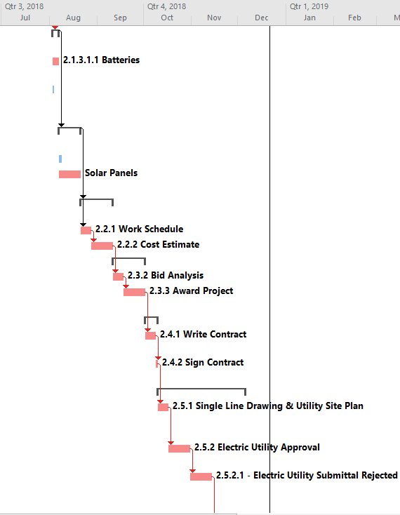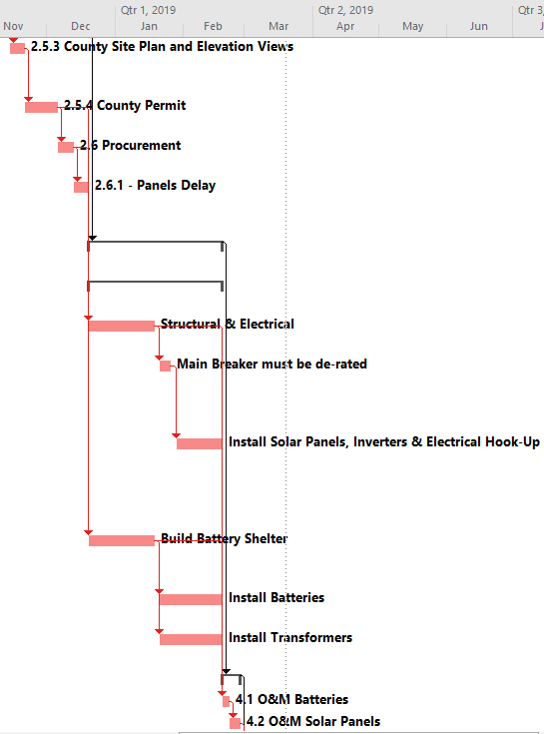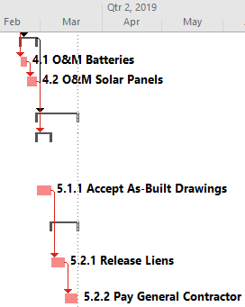

The project now takes approximately 40 weeks (214 days). Starting on May 16, 2018, Solar Power panel project will be finished by Mar 19, 2019, which means five weeks later. Except for non-critical activities *(1.1.1 Risk Analysis, 1.1.2 Electric/Solar Load Analysis, 2.1.3.1.2 Solar Panels and 2.1.3.2.1 Batteries),* all other activities are on the critical path. In other words, the network, as planned, is not considered sensitive because it has one critical path and non-critical tasks with a quite low value of slacks. Having it in mind, as project managers, we should devote much attention to managing the critical path.

# Conclusion

We have completed the roof installation under our one-million-dollar budget. Surprisingly, we were also able to finish in 40 weeks, before our 10-month deadline (43 weeks). The project under ideal circumstances would have taken 36 weeks, but we were prepared to face the obstacles along the way. We installed the system without reducing the planned size.